From the Office of the Dean

School of Engineering & Technology

Building 30/Level 2

CQUniversity Australia

Bruce Highway

Rockhampton QLD 4702

Tel: 07 4930 9562

Email: s.t.hall@cqu.edu.au

RAugust 21, 2020

Mathew Gallehawk

mathew.gallehawk@cqumail.com

Dear Mathew

I am writing to offer my congratulations on the outstanding level of achievement that you have attained in your studies for Term 2 2019.

The School of Engineering and Technology commends the members of its student community who achieve a high level of academic performance. I am very pleased to advise that your academic performance places you in this category, since you received a High Distinction for: CG36 Diploma of Information and Communication Technology

I am aware of the high level of commitment required to achieve this level of academic performance, and I encourage you to maintain your current high standard of academic performance in subsequent terms, and to give consideration to future enrolment in courses offered by CQUniversity.

Again, congratulations on your achievement and best wishes for your future studies.

Yours sincerely

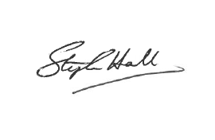

***Professor Steve Hall***

Dean

School of Engineering & Technology

*CQUniversity Australia*